**Name: VISHNU SADASIVAN**

**Roll No: 52**

**Batch: MCA-B**

**Date:10/06/2022**

**ADVANCED DATABASE MANAGEMENT SYSTEM LAB**

**Experiment No.: 11**

**Aim**

Q1.Create a student table with fields id,name,subject1,subject2,subject3 and total,percentage. For each entry of row, update total marks and percentage using triggers in SQL

**Procedure**

1. **CREATING TABLE**

CREATE TABLE STUDENTINFOR (ID INT(20) PRIMARY KEY , NAME

VARCHAR(20) NOT NULL, SUBJ1 INT,SUBJ2 INT,SUBJ3 INT,TOTAL

INT(30),PERCENTAGE FLOAT );

1. **CREATE TRIGGER ON STUDENTINFOR**

CREATE TRIGGER MARKCHANGE BEFORE INSERT ON STUDENTINFOR FOR EACH ROW SET NEW.TOTAL=NEW.SUBJ1+NEW.SUBJ2+NEW.SUBJ3, NEW.PERCENTAGE=NEW.TOTAL /300 * 100 ;

1. **INSERTING VALUES TO STUDENTINFOR**

INSERT INTO STUDENTINFOR(ID,NAME,SUB1,SUB2,SUB3)VALUES(1002,"RAM",88,99,54);

INSERT INTO STUDENTINFOR(ID,NAME,SUB1,SUB2,SUB3)VALUES(1004,"JOHN",66,79,54);

INSERT INTO STUDENTINFOR(ID,NAME,SUB1,SUB2,SUB3)VALUES(1006,"THOMAS",38,79,94);

1. **STUDENTINFOR  TABLE**

SELECT *FROM STUDENTINFOR;

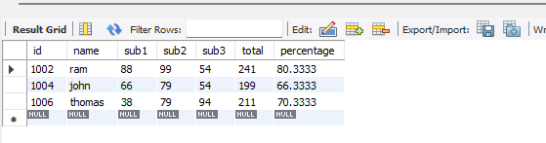

 Q2.Create a Trigger for student table that will update another table shows the name, total marks and percentage

**PROCEDURE**

**STEP 1: CREATE DATABASE**

CREATE DATABASE DBMSTRIGER;

USE DBMSTRIGER;

**STEP 2: CREATE TABLE STUDENT**

CREATE TABLE STUDENT(ID INT PRIMARY KEY,NAME VARCHAR(20),SUBJECT1 INT,SUBJECT2 INT,SUBJECT3 INT,TOTAL_MARKS INT,PERCENTAGE FLOAT);

**STEP 3: CREATE TRIGGER ON STUDENT TABLE**

CREATE TRIGGER TRIG_MARK BEFORE INSERT ON STUDENT FOR EACH ROW SET NEW.TOTAL_MARKS = NEW.SUBJECT1 + NEW.SUBJECT2 +NEW.SUBJECT3,NEW.PERCENTAGE =NEW.TOTAL_MARKS / 150 * 100;

**STEP 4: CREATE ANOTHER TABLE**

CREATE TABLE MARKS(MARKID INT PRIMARY KEY AUTO_INCREMENT,NAME VARCHAR(20),TOTAL_MARKS INT,PERCENTAGE FLOAT);

**STEP 5: CREATE TRIGGER**

CREATE TRIGGER MARKS AFTER INSERT ON STUDENT FOR EACH ROW INSERT INTO MARKS(NAME,TOTAL_MARKS,PERCENTAGE)VALUES(NEW.NAME,NEW.TOTAL_MARKS,NEW.PERCENTAGE);

**STEP 6: INSERT RECORDS**

INSERT INTO STUDENT (ID,NAME,SUBJECT1,SUBJECT2,SUBJECT3) VALUES(1001,'THOMAS MARTIN',42,44,48);

INSERT INTO STUDENT (ID,NAME,SUBJECT1,SUBJECT2,SUBJECT3) VALUES(1002,'DON BOSCO',44,46,50);

SELECT *FROM STUDENT;

SELECT *FROM MARKS;

**OUTPUT**

TABLE MARKS

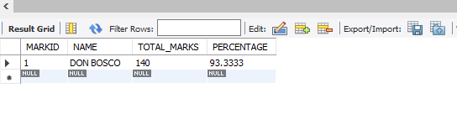

TABLE STUDENTS

